Fun with Sumerian Kings, Astrophysics, and GitHub Copilot

Introduction
The Sumerian King List is a composite historical text that records rulers and reign lengths for several early Mesopotamian cities and is preserved in multiple manuscript traditions (Jacobsen, 1939). Many reigns—particularly those assigned to antediluvian rulers—are recorded as lasting hundreds to thousands of years and are widely regarded as symbolic rather than historical.
This report presents an exploratory and speculative analysis that combines these ancient records with relativistic physics, galactic structure modeling, and probabilistic astrobiology. The motivating idea was to reinterpret the unusually long reign lengths recorded for the kings of the Sumerian city of Kish as apparent time-dilated durations, under the hypothetical assumption that Kish could be modeled as a spacecraft originating from another stellar system.
To rapidly prototype, evaluate, and extend this analysis, GitHub Copilot was employed as an interactive coding assistant. Three primary questions were investigated:
- What relativistic velocity would best fit the recorded reign durations under special relativistic time dilation?
- How many G-type main-sequence stars (G dwarfs) lie within the corresponding travel distance, accounting for Galactic structure (Reid et al., 2009)
- Given that stellar population, what is the probability that an advanced technological civilization could be the origin of such a spacecraft, as estimated using the Drake equation (Drake, 1961)

Sumerian Kings List for the City of Kish
There are lists of Sumerian Kings from many ancient Sumerian cities but a single city, Kish, was selected for this analysis in order to quickly explore the data. Many of the Sumerian Kings in these records are recorded to have reigned for hundreds, at times thousands of years.
This table presents the reign lengths of the Kings of Kish as recorded in the Sumerian King List. Durations are expressed in modern decimal years and in base-60 notation, reflecting the sexagesimal numerical system characteristic of ancient Mesopotamian administration. The data exhibit strong clustering around multiples of 60, suggesting symbolic or schematic construction rather than historical chronology. Base-60 representations are given as (n × 60 + r), where r < 60. Period classification follows standard Assyriological convention.

King | Period | Reign Length (years) | Reign Length (base-60)
Jushur | Antediluvian | 1200 | 20 × 60 + 0
Kullassina-bel | Antediluvian | 960 | 16 × 60 + 0
Nangishlishma | Antediluvian | 670 | 11 × 60 + 10
En-tarah-ana | Antediluvian | 420 | 7 × 60 + 0
Babum | Antediluvian | 300 | 5 × 60 + 0
Puannum | Antediluvian | 840 | 14 × 60 + 0
Kalibum | Antediluvian | 960 | 16 × 60 + 0
Zuqaqip | Antediluvian | 900 | 15 × 60 + 0
Atab | Antediluvian | 600 | 10 × 60 + 0
Mashda | Antediluvian | 840 | 14 × 60 + 0
Arwium | Antediluvian | 720 | 12 × 60 + 0
Etana | Antediluvian | 1560 | 26 × 60 + 0
Balih | Antediluvian | 400 | 6 × 60 + 40
En-men-lu-ana | Antediluvian | 1200 | 20 × 60 + 0
Dumuzid, the Shepherd | Antediluvian | 1000 | 16 × 60 + 40
Ensipazi-anna | Antediluvian | 700 | 11 × 60 + 40
Enmengal-ana | Antediluvian | 670 | 11 × 60 + 10
Dumuzid, the Fisherman | Antediluvian | 1000 | 16 × 60 + 40
En-me-barage-si | Postdiluvian | 900 | 15 × 60 + 0
Aga | Postdiluvian | 625 | 10 × 60 + 25
Table 1. Kings of Kish with reign lengths in decimal and base-60 notation.

Statistical Summary
Number of reigns: 20
Mean reign length: 823.2 years
Median reign length lies close to major multiples of 60 years.
(One notes that a significant fraction of reign lengths are exact or near-exact multiples of 60, supporting interpretations of numerological structuring in the King List.)

Reign Durations Interpreted as Relativistic Time Dilation

Speed Estimation
This analysis began by interpreting the recorded reign durations as time-dilated intervals, assuming that the proper lifetime of each king was constrained by biologically plausible limits. The relativistic time dilation relation,
$$Δt=γΔτ,γ=\frac{1}{\sqrt{1-v^{2}/c^{2}}},$$
was used as the forward model.
GitHub Copilot was instructed to:
- Ingest the list of reign lengths,
- Assume a truncated normal distribution for proper lifetimes (biological constraints),
- Perform a Monte Carlo fit to infer the effective velocity of the hypothetical “Kish spacecraft.”
Copilot autonomously generated Python code implementing the relativistic model and executed the simulation. It used a truncated normal in order to restrict the distribution to an interval for life expectancy of the kings. It executed the program and displayed the results for the Kish spaceship. Please see below:
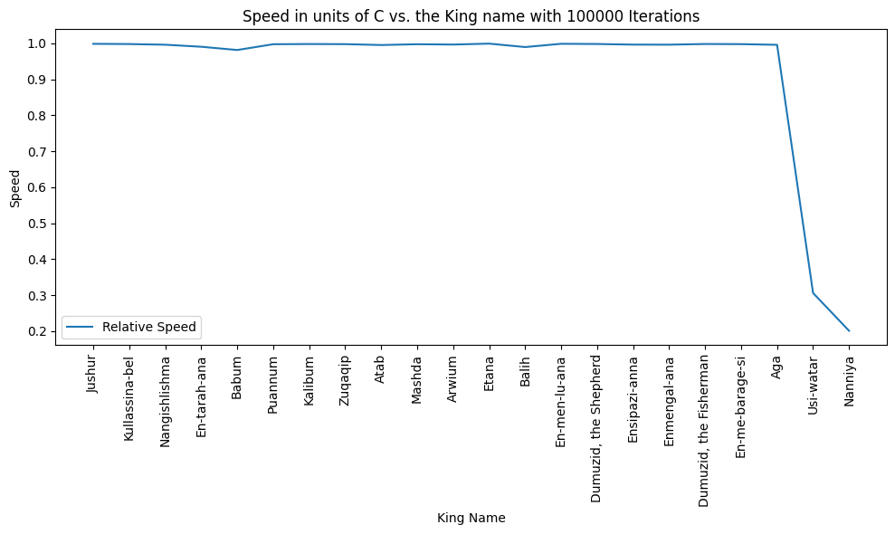
and

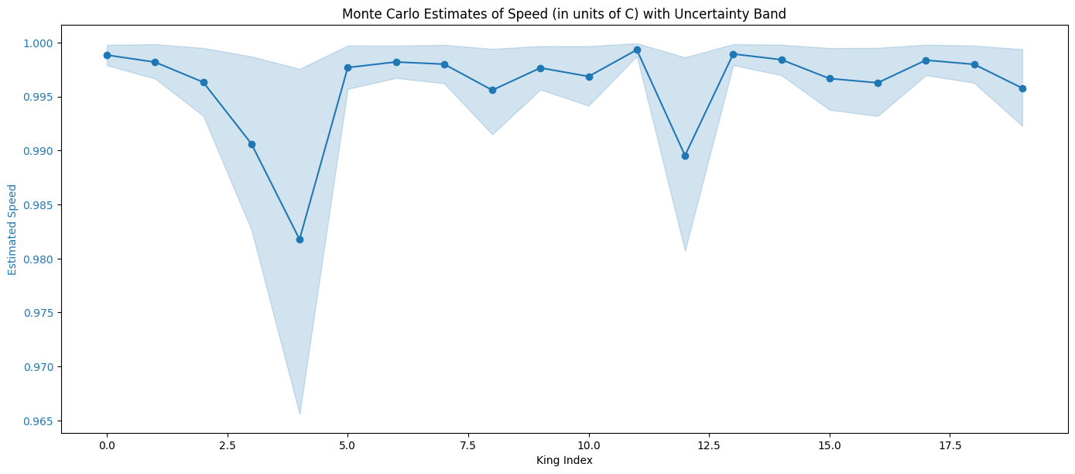

Distance Estimation
The generated code was manually modified to compute the implied travel distance corresponding to the inferred velocity and duration. The resulting estimate was:
$$D≈1.64×{10}^{4}\text{ light years}.$$
This distance was used as the input scale for subsequent astrophysical calculations.

G-Type Star Estimation
Estimation of G-Type Main-Sequence Stars
The Galactic Model
Copilot was next instructed to estimate the number of G-type main-sequence stars (G dwarfs) within a radius of 16,418.86 light years from Earth.
Without explicit instruction, Copilot incorporated the spiral arm structure of the Milky Way by loading parameters from the Reid et al. spiral arm model. A Monte Carlo sampling approach was again employed, despite not being explicitly requested.
The model included a small sensitivity sweep that estimated the number of G-type stars lying within spiral arms for several assumed total Galactic G-star populations:
5$×{10}^{9}$, 1$×{10}^{10}$, 2$×{10}^{10}$, 5$×{10}^{10}$.
For a fiducial value of $2×{10}^{10}$G-type stars in the Milky Way, the estimate yielded approximately:
$$N_{G}≈1.57×{10}^{6}$$
within the relevant volume.
It should be noted that Copilot independently and without any input proceeded to take into account the spiral arm structure of the Milky Way galaxy by finding a file that contained the Reid spiral arms parameters and loading it into Python when running the calculations.)

Visualization
Copilot was also instructed to augment the existing code with a graph that depicts the distribution of the g type stars in the spiral arms of the galaxy. It altered the code, ran it, and the code displayed the following diagram.
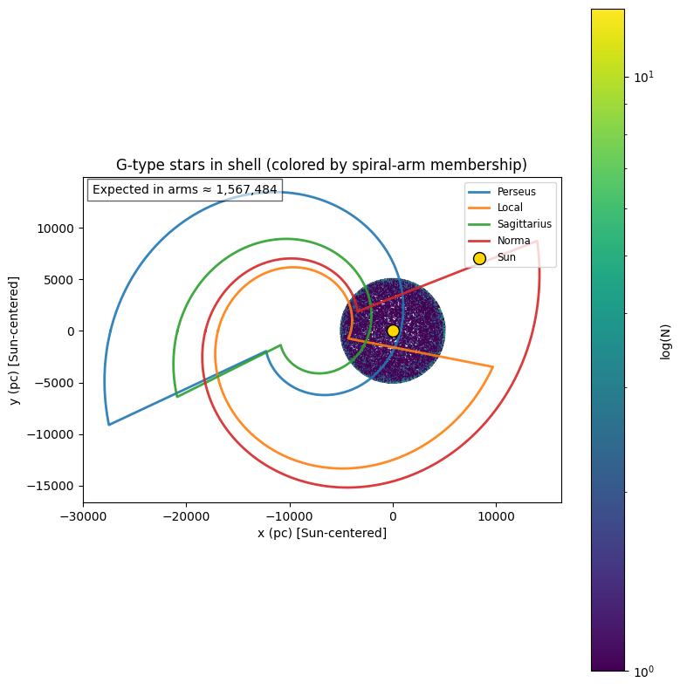
Further interactions with Copilot ensued in which different types of graphs and output were suggested by it and were accepted. Each interaction enhanced the code and produced more interesting graphics and graph types within Python’s graphics libraires; e.g.
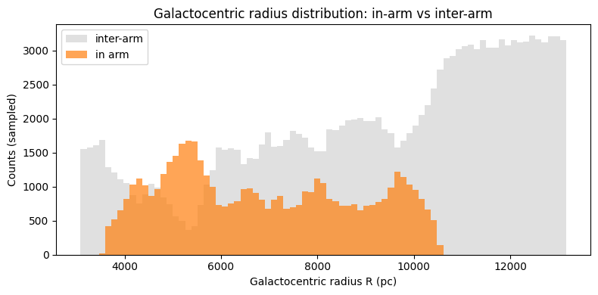
The interactions with Copilot in this instance were highly educational as one was exposed to new astrophysical knowledge, i.e. Reid spiral arm model and new graphics capabilities of Python.

Drake Equation Estimation
The third major task given to Copilot was to estimate the number of advanced civilizations, using Drake’s equation, within the spiral arms.

Monte Carlo Drake Model
Using the estimated population of G-type stars, Copilot constructed a Monte Carlo implementation of the Drake equation to estimate the probability of advanced technological civilizations within the sampled volume.
The baseline Monte Carlo results were:
- Number of G-type stars: $1.604×{10}^{6}$
- Monte Carlo samples: ${10}^{6}$
Summary statistics:
- Median per-star probability: $3.84×{10}^{-13}$
- Mean per-star probability: $1.89×{10}^{-7}$
- Median $P(≥1)$: $6.16×{10}^{-7}$
- Mean $P(≥1)$: $2.48×{10}^{-2}$

Scenario-Based Sensitivity Analysis
Upon confirmation, Copilot implemented a sensitivity analysis using three distinct parameter regimes:
Optimistic Scenario
- Life, intelligence, and technology fractions ≈ 1
- Technological lifetime $L={10}^{8}$yr
- $P(≥1)≈1$
Moderate Scenario
- $f_{l}$=0.01, $f_{i}$=0.01, $f_{c}$​=0.1, L=${10}^{6}$ yr
- $P(≥1)≈1.6×{10}^{-4}$
Pessimistic Scenario
- Extremely rare life and intelligence
- $L={10}^{3}$yr
- $P(≥1)≈0$
These scenarios span approximately 14 orders of magnitude in per-star probability.
Copilot inquired and after confirmation added and ran a sensitivity analysis (Baseline / Optimistic / Pessimistic) that samples alternate priors and saved the results as well as creating a comparison figure: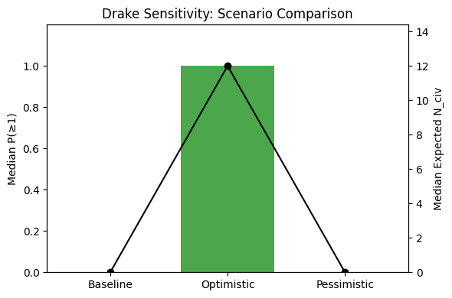

Interpretation
Key Findings
- Per-star probability estimates vary from ${10}^{-16}$to ${10}^{-2}$, depending on assumptions.
- Population effects dominate: even extremely small per-star probabilities can yield non-negligible $P(≥1)$when millions of stars are considered.
- Sensitivity to $f_{l}$, $f_{i}$, and $L$is extreme; small parameter changes drastically alter outcomes.
These results highlight the Fermi Paradox: under many plausible assumptions, detectable civilizations should exist, yet no confirmed evidence is observed.

Copilot Interactions
The analysis evolved from standalone Python scripts, created by Copilot for each task, to Jupyter Notebooks, converted from the initial files by CoPilot, to facilitate interactive exploration. Copilot autonomously converted code formats, configured Jupyter support in Visual Studio Code, and generated provenance and reproducibility comments.
Throughout the sessions, Copilot consistently provided explanations of its planned actions, enhancing transparency and user trust in the computational process.
Computational Environment
All computations were performed using:
- Visual Studio Code 1.107.1
- Python 3.11.9
- GitHub Copilot — Raptor mini (Preview)
- Windows 10 x64 (NT 10.0.26200)
- Intel Core i9-13900, 32 GB RAM
All Python executions completed in under 8 seconds.

References
Jacobsen, T. (1939). The Sumerian King List. Assyriological Studies No. 11. University of Chicago Press.
Reid, M. J., Menten, K. M., Brunthaler, A., Zheng, X. W., Moscadelli, L. & Xu, Y. 2009, ApJ, 693, 397
Drake, F. D. 1961, Physics Today, 14(4), 40

Repository

https://github.com/Crimson-Reason/Sumerian-Kings

